SCIENCE TEACHER’S ASSOCIATION OF QUEENSLAND (STAQ)

                                                                                                QUEENSLAND SCIENCE CONTEST (QSC)

                        The following are two winners from the 2016 STAQ Queensland Science Contest, which was partially sponsored by Rowe Scientific Pty Ltd.

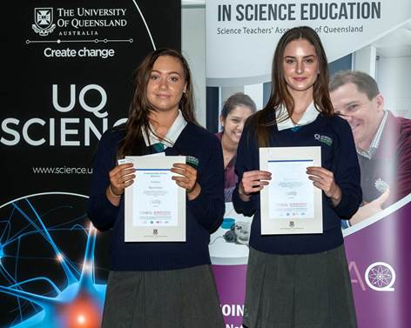

            Our congratulations to (left to right) Skye Every and Bella James. Their science projects were entitled “ Evolution of the Human Skull”, and “The Carbon Cycle”, respectively.

Thanks and regards,